**Product Requirements Document**

Product: Interactive Dashboard Philadelphia City Council Districts w/ Determinants of Health

Drexel University Dornsife School of Public Health

Urban Health Collaborative (UHC)

Project Managers: Dr. Alina Schnake-Mahl, Dr. Stephanie Hernandez, Dr. Tamara Rushovich, Ran Li, Amber Bolli

Date of Creation: 3/31/2025

Version 1.2

**Elements to be included in the Dashboard:**

**Title:** Health ofPhiladelphia City Council Districts

**Introduction**

The health of Philadelphia residents varies drastically across the city – differences that reflect broader disparities in income, opportunity, and access to essential resources. These are not just personal choices made by the city’s residents – they are shaped by federal, state and local laws and policies.

This project takes a closer look at those conditions by analyzing publicly available data and mapping key health indicators and social determinants of health across all 10 Philadelphia City Council Districts. By doing this, we aim to provide a clearer picture of how politics and geography intersect to shape the health of Philadelphians.

Our goal is to equip all 17 Philadelphia City Council members and the public with actionable, district-level insights that can guide and empower more equitable policy and investment into our city. By connecting this data to City Council Districts, we hope this project continues to grow and support effective policy solutions that can promote equality and better health for all Philadelphians.

**Find your council district:** <https://philacitycouncil.maps.arcgis.com/apps/instant/lookup/index.html?appid=9cf0fb3394914cd0a8a7f22ea1395d55>

**Instructions for use:**

To explore the data, use the drop-down menu provided below to select the health outcome that interests you. Once selected, the dashboard will display a bar graph comparing all 10 City Council Districts, along with a spatial map that visualizes how this outcome varies across the city.

**Functionality of Dashboard:**

* A drop-down list of selectable determinants of health at the top of the dashboard. Underneath the instructions how to use the Dashboard.
* 2 graphs/maps will output from selecting a determinant of health. One will be of a simple bar graph that displays that input across the 10 districts. The other will be a spatial map of the 10 districts of Philadelphia. These should be side by side.
  + The spatial map should have the district number displayed. As well as having some graduated colors (darker = higher value) to reflect input changes across the districts.
  + The bar graph should have a line for the city average. (*Need to add city averages to combine measures dataset)
* If you hover over/click a district on the spatial map, a small text box will show how many of that input are in that district and the number of the district.
  + It would also be if you select a district, the bar graph color changes for the district you selected to highlight it better.
* The only determinant of health that should not have a bar graph is Heat Vulnerability Index. The range is from negative to positive, so a bar graph will not look right. The scale should be from Very Low to Very High Risk and would best be shown with graduated colors on the spatial map only. An example is shown below.

* Also, Data documentation (currently an excel file) we would like to embed into the dashboard. If people click on it, it should pull up the excel (see “About the data” bullet below).

**Rough Main visualization of Dashboard:**

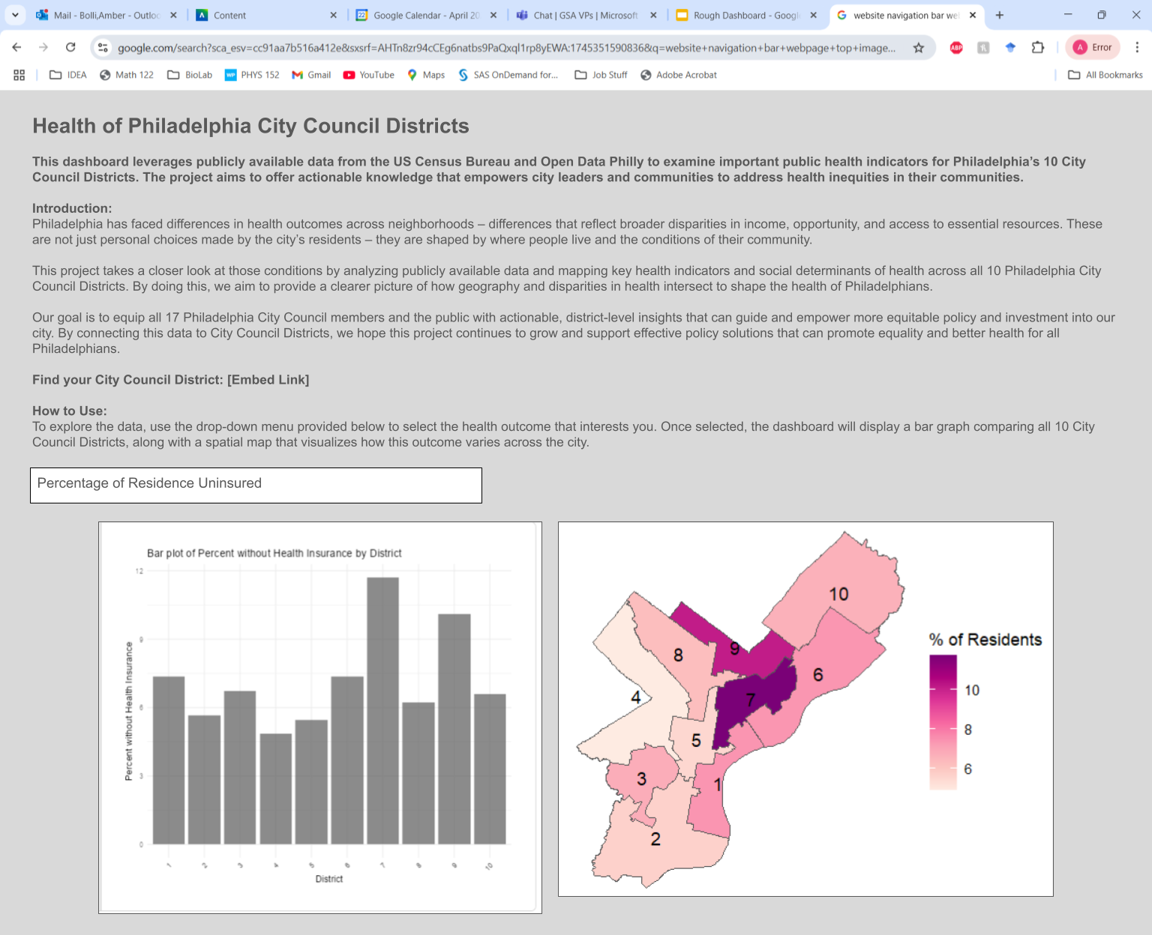

**About the Data**: Link to data documentation page that details data source and notes about the metrics. [Embed Link]

* E.g. A screenshot of a spreadsheet

  AI-generated content may be incorrect.

**Acknowledgements, Citation, contact us:**

**Authors**: Amber Bolli, Tamara Rushovich, Ran Li, Stephanie Hernandez, Alina Schnake-Mahl,

**Sponsor:** IDEA Fellowship

**Links to related work**

* + [Congressional District Health Dashboard](-%09https:/www.congressionaldistricthealthdashboard.org)
  + [Rushovich T, Nethery RC, White A, Krieger N. Gerrymandering and the Packing and Cracking of Medical Uninsurance Rates in the United States. J Public Health Manag Pract. 2024;30(6):832-843. doi:10.1097/PHH.0000000000001916](https://pubmed.ncbi.nlm.nih.gov/39190647/)
  + [Schnake-Mahl A, Anfuso G, Goldstein ND, et al. Measuring variation in infant mortality and deaths of despair by US congressional district in Pennsylvania: a methodological case study. *Am J Epidemiol*. 2024;193(7):1040-1049. doi:10.1093/aje/kwae016](https://pubmed.ncbi.nlm.nih.gov/38412272/)
  + [Schnake-Mahl A, Anfuso G, Bilal U, et al. Court-mandated redistricting and disparities in infant mortality and deaths of despair. *BMC Public Health*. 2025;25(1):1058. Published 2025 Mar 19. doi:10.1186/s12889-025-22221-5](https://pmc.ncbi.nlm.nih.gov/articles/PMC11921522/)
  + [Schnake-Mahl A, Anfuso G, Hernandez SM, Bilal U. Geospatial Data Aggregation Methods for Novel Geographies: Validating Congressional District Life Expectancy Estimates. *Epidemiology*. 2025;36(1):119-125. doi:10.1097/EDE.0000000000001797](https://pubmed.ncbi.nlm.nih.gov/39329432/)
  + [Spoer BR, Chen AS, Lampe TM, et al. Validation of a geospatial aggregation method for congressional districts and other US administrative geographies. *SSM Popul Health*. 2023;24:101511. Published 2023 Sep 4. doi:10.1016/j.ssmph.2023.101511](https://pmc.ncbi.nlm.nih.gov/articles/PMC10498302/)

**Citation**: Urban Health Collaborative, Drexel Dornsife School of Public Health, *Health of**Philadelphia City Council Districts Dashboard*, 2025

**Contact Us**: Please reach out to [UHC@drexel.edu](mailto:UHC@drexel.edu) with any questions

**Not shown on Dashboard, but for our own Documentation:**

**Objectives**

This product aims to create an interactive dashboard that will display all 10 Philadelphia City Council Districts for the 2024 council districts. The goal of this dashboard is to inform the 17 City Council members of the policy issues that are most affecting their respective districts.

We identified a set of health determinants based on the concerns of the current Philadelphia City Council. By clicking on one of the 10 districts, different determinants of health will display and compare that district with the others. These determinants currently include: the percentage with no health insurance, the heat vulnerability index, the median age, the median household income, the number of fatal car crashes, the number of fatal and nonfatal shootings, the percentage of owner occupied versus renter occupied homes, the percentage of homes that lack a complete kitchen and/or complete plumbing, the educational attainment status of residents, and the percentage of each race of residents.

**Stakeholders**

**Target group**: Current Philadelphia City Council District Members

**Philadelphia Department of Public Health (PDPH):** To help inform PDPH about variation in key health determinants across districts.

**UHC:** This dashboard can build on the current UHC repository and will be beneficial for future students to continue (ex. Future IDEA Fellows).

**Milestones**

Bike Accident Presentation to Council: 10/08/2024

Draft of Product: 03/31/2025

Planned Finish Date: 06/06/2025

IDEA Presentation Date: 06/06/2025